XML Parsers

This is a software library/ package that provides interfaces for client applications to work with an XML document.

Parsers are designed to read XML and create ways for programs to use XML.

Validates the document and checks that the document is well formatted.

Visual representation

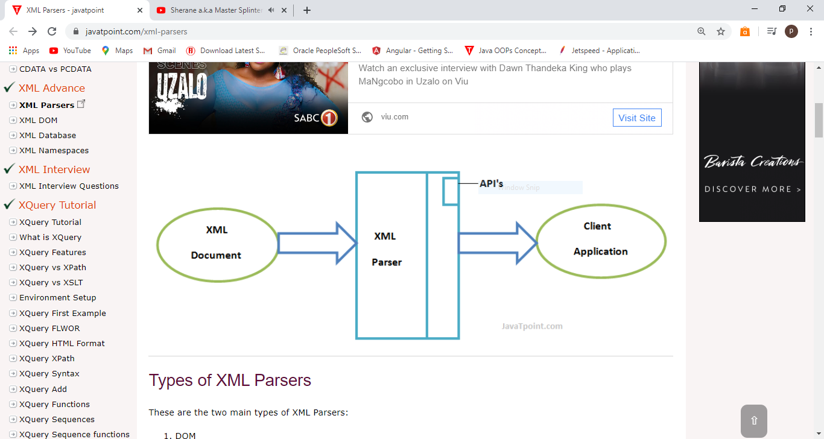

Types of XML parsers include:

* DOM
* SAX

DOM/Document Object Model

This is an object which contains all the information of an XML document.

The DOM parser implements the DOM API.